1.

public class Cuboid<E> {  
 //private E cuboid; // The generic cuboid  
 private E length, breadth, height; // Generic dimensions of the cuboid  
  
 public Cuboid(E length, E breadth, E height) {  
 this.length = length;  
 this.breadth = breadth;  
 this.height = height;  
 }  
  
 // Set Methods  
 public void setLength(E length) { this.length = length; }  
 public void setBreadth(E breadth) { this.breadth = breadth; }  
 public void setHeight(E height) { this.height = height; }  
  
 // Get Methods  
 public E getLength() { return length; }  
 public E getBreadth() { return breadth; }  
 public E getHeight() { return height; }  
  
 // toString() Method  
 @Override  
 public String toString() {  
 return "Length: " + length + "\n" + "Breadth: " + breadth + "\n" + "Height: " + height;  
 }  
}

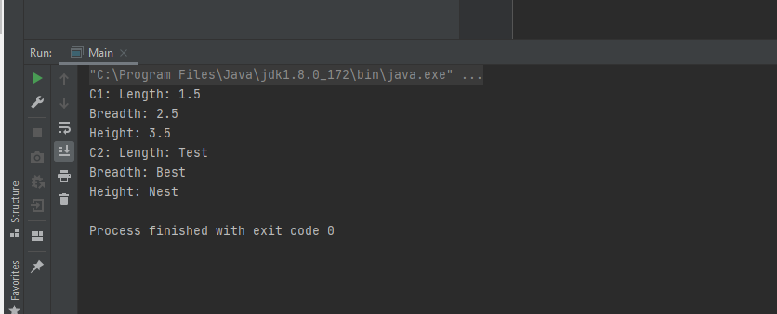

2.

public class Cuboid<E extends Number> {  
 private E length, breadth, height; // Generic dimensions of the cuboid  
 private double volume;  
  
 public Cuboid(E length, E breadth, E height) {  
 this.length = length;  
 this.breadth = breadth;  
 this.height = height;  
 }  
  
 // Set Methods  
 public void setLength(E length) { this.length = length; }  
 public void setBreadth(E breadth) { this.breadth = breadth; }  
 public void setHeight(E height) { this.height = height; }  
  
 // Get Methods  
 public E getLength() { return length; }  
 public E getBreadth() { return breadth; }  
 public E getHeight() { return height; }  
  
 public double getVolume() {  
 return height.doubleValue() \* breadth.doubleValue() \* height.doubleValue();  
 }  
  
 // toString() Method  
 @Override  
 public String toString() {  
 return "Length: " + length + "\n" + "Breadth: " + breadth + "\n" + "Height: " + height;  
 }  
}

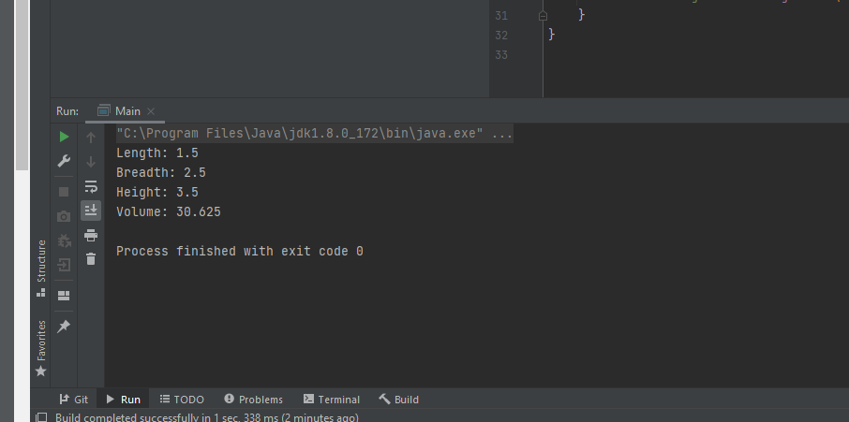

4.

public class Map<E, T> {  
 private E key;  
 private T value;  
  
 public Map(E key, T value) {  
 this.key = key;  
 this.value = value;  
 }  
  
 // Set Methods  
 public void setKey() { this.key = key; }  
 public void setValue() { this.value = value; }  
  
 // Get Methods  
 public E getKey(E key) { return key; }  
 public T getValue(T value) { return value; }  
  
 // toString() Method  
 public String toString() {  
 return "Key: " + key + " | Value: " + value;  
 }  
}

